

# Real Time Identity Ribbon Detection Based on Histogram Oriented Gradient and Linear Supported Vector Machine

**Submitted by**

Md. Tamim Hasan

ID:181-35-2432

Department of Software Engineering

Daffodil International University Supervised by

**Supervisor Name**

Kaushik Sarkar

Assistant Professor

Department of Software Engineering

Daffodil International University

A thesis submitted in partial fulfillment of the requirement for the degree of Bachelor of Science in Software Engineering

**Department of Software Engineering**

**DAFFODIL INTERNATIONAL UNIVERSITY**

Summer – 2021

# 

# 

**ACKNOWLEDGEMENT**

Frist, I express our heartiest thank and gratefulness to almighty Allah for this divine blessing makes us possible to complete the final year thesis successfully.

I grateful and wish our profound indebtedness to **Kaushik Sarker**, Assistant professor & Associate Head, Department of SWE Daffodil International University, Dhaka. Deep Knowledge & keen interest of our supervisor in the field of “Machine Learning” to carry out this Document. His endless patience, scholarly guidance, condition encouragement, constant and energetic supervision, constructive criticism, valuable advice, reading many inferior draft and correction them at all stage have made it possible to complete this thesis.

I would like to express out heartiest gratitude to **Dr. Imran Mahmud**, Associate Professor & Head In-Charge Department of SWE, for this kind help to finish my thesis and **Ms. Nusrat Jahan**, Assistant Professor and **Afsana Begum**, Assistant Professor and also to other faculty member and the staff of the SWE department of Daffodil International University.

I would like to thank our entire friend at Daffodil International University, who took part and help me in this discussion while completing the course work.

Finally, I must acknowledge with due respect the constant support and patients of our parent.

|  |
| --- |
| TABLE OF CONTANT **APPROVAL** ii  **DECLARATION** iii  **ACKNOWLEDGEMENT** iv  **TABLE OF CONTANT** v  **LIST OF FIGURE** vii  **ABSTRACT** viii  **CHAPTER 1: INTRODUCTION** 1  1.1 Background 1  1.2 Motivation of the Research 2  1.3 Object 2  1.4 Research Scope 3  1.5 Thesis Organization 3  **CHAPTER 2: LITERATURE REVIEW** 4  2.1 Background 4  2.2 Literature Review 5  **CHAPTER 3: METHODOLOGY** 7  3.1 Introduction 7  3.2 Explain the Procudure of Data Collection and Dataset 8  3.3 Explain the Data Preprocessing System 9  3.4 Explain the Data Analysis Techniques 10  3.4.1 Suported Vector Machine 1 10  3.4.2 Histogram Oriented Gradient 17  3.4.3 You Only Look Once 21  3.5 Summary 25  **CHAPTER 4: RESULTS AND DISCUSSION** 26  4.1 Introduction 26  4.1.1 Experiment Result 27  4.1.2 Descriptive Analysis 28  **CHAPTER 5: CONCLUSIONS AND RECOMMENDATIONS** 29  5.1 Findings and Contributions 29  5.2 Recommendations for Future Works 30  REFERENCES 31 |

# LIST OF FIGURES

Figure 3.1: Block Diagram and segmentation for different kind of ribbon 7

Figure 3.2: Data collecting specific distance and agnle 8

Figure 3.4.1.1: Supported vector Machine(SVM) Classification Technique 11

Figure 3.4.1.2: Draw a line separate two classes 12

Figure 3.4.1.3: Simple cut to divided into two classes 13

Figure 3.4.2.1: 3 Histogram of a gredient 18

Figure 3.4.2.2: 4 Histogram of a cell 19

Figure 3.5.2: Input image devided into grid 22

Figure 3.5.3: The Bounding Box(YOLO) 23

Figure 3.5.4: The sample work of IOU(YOLO) 24

Figure 4.1.1: Output of Teacher.jpg 26

Figure 4.1.2: Output of Student.jpg 27

# ABSTRACT

Over the year’s picture are one of the major information sharing outline. Nowadays Image segmentation is used to identifying the object as well as boundaries in the images. Due to the advancement of computer vision technology I try to investigate different image segmentation techniques on ribbon images. There are several algorithms proposed for segmentation an image. In this paper I use binary image segmentation for image classification. Binary image segmentation is the process to classifying the pixel of the image into two different categories: pixels that belong to an image's foreground objects and pixels that belong to an image's background objects. In this paper use YOLO and HOG for detect id card ribbon. This method has achieved a very good result comparing with other techniques. A ribbon data set of real time image was tested. More than 90% accuracy has been achieved, which appears to be good and promising by comparing the performance obtained with the relevant work recently reported.

**Keywords:** Object Detection, YOLO, HOG, Object Classification;

# CHAPTER 1

# INTRODUCTION

## Background

The value of computer vision object detection is rising day by day. Digital image process plays an excellent trip in day-by-day life application like natural picture, medical pictures, satellite pictures and the fourth. Image detection could be a vintage subject within the field of image process and is also a hotspot and hub of image processing technique. Detection of image is an important part of processing of images. Detection of the fluctuated segment among the particles is to an excellent degree crucial to restorative decision. The method of partitioning an image into relevant region or artifact in computer vision image detection. Detection has a range of strategies like: Edge detection- this technique distinguished the edge and identifies the boundaries in an object. It is a special approach used for detection the edges. That attempts to capture artifact’s significant properties in the picture, Region Growing- building pixels into larger region based on predefined seed pixels, growing parameters and stopping condition, A novel approach to object detection call YOLO. Classifiers have been repurposed to do detection in previous work on object detection. Rather consider object detection as a regression issue with geographically separated bounding boxes and class probabilities. From entire photos of an environment, a single neural network predicts bounding boxes and class probabilities. The YOLO model processes images at a rate of 45 feature per second in real time. Fast YOLO a smaller variant of the network, processes 155 frames per sound while reaching double the mAP of other real time detector. The object detector uses the technique to convert an input image into SxS gride in while each cell predicts only object. If numerous small objects exit in a single cell, YOLO will be unable to detect them, resulting in missed object detection. In my case the recognizable proof is still a challenging assignment due to assortment of shape, color of design in ribbons, changeability of deformity sorts and nearness of stem and so on. Object detection is a phase used to describe a set of tasks that are used to recognized object in digital images. R-CNNs, or Region-Based Convolutional neural networks, are a set of model-optimized algorithm for addressing object identification system thar are geared for speed and real-time use are known as You Only Look Once detection.

## Motivation of the Research

Image detection is a very important topic in present era. In deep learning there are many significant works about image detection. Not only object detection topic it also very important role in security also. In this topic Ribbon detection is very important topic for security also. This idea is use for detect an identity as well as also use for security also. The motive of object detection is to recognize and local all know object in a scene like daffodil ribbon.

There are many kinds of ribbon available in different university. But this paper is just for Daffodil International University. Object detection can help to improve the security system in private sector. Camera can use computer vision to monitor the territory and uninvited guest at night. With the inclusion of identification technologies in the system, it can also determine the personality of the person.

## Objective

The aims of this research are to find out and analysis a technique that can help separate local student or teacher ribbon and thus make an appropriate result. The propose system is user-friendly, easy to execute and can be easily implemented in any process.

> To show to our university visitor the local ribbon.

> To make the people of our unitarity conscious of our all member.

> To contribute to our country’s research field.

> To make a security process by ribbon.

>To use technique for segmenting images.

## 1.4 Research Scope

The scope refers to the set of resources to which access is granted. It’s critical to understand scope when assigning a position so that everyone can grant a security principle only the access it requires. Limiting the scope reduces the number of resources at risk if the security principle is over breached.

Object recognition is a word that refers to a set of tasks that are used to identify object in digital picture. R-CNNs, or Region-based Convolutional Neural Networks, are a set of model optimized algorithms for addressing task. You Only Look Once, is a type is object recognition system that is geared for speed and real time use.

In future this paper adds some new feature like add more different kind of ribbon for detection. Daffodil can use this use this technique for security purpose. Not only daffodil this technique can uses for every security step.

## 1.5 Thesis Organization

Ribbon is a important part of security sector. It would be very strong part of security sector. In the main gate or entry option it would a very strong part. Anyone who don’t have their id they can’t entry in their organization.

Other hand we though to know about the ribbon in different sector member. And in this work in this project. We thought of method that will open to the youth society by taking photo to identify the ribbon. For this problem we need to classifier system. In classifier system we need to do image processing like segmentation. My proposed system I will try to investigate different technique for find the better result.

**1.** I will get a research-based project (There is no work on ribbon detection system in our country util now. I believe that lot of information will come out in this research)

**2.** Can know about different ribbon (This system not only detect ribbon but also provided information about different ribbon)

**3.** Know about Daffodil different label staff ribbon not only staff but also student also.

**3.** Show the new detection system to future generations and country.

CHAPTER 2

# LITERATURE REVIEW

## 2.1 Background

In this sector, several studies carried out by researchers in the field of image segmentation, ribbon detection, image categorization, image detection, classification in addressed. Different research work that is actually done relate this image detection field.

Object detection is an important test, yet challenging vision test. It is a critical part of many applications such as image search, image auto-annotation and scene understanding, object tracking. Moving object tracking of video image sequence was one of the most important subjects in computer vision. It had already been applied in many computers vision fields, such as smart video surveillance (Arun Hampapur 2005), Artificial intelligence, military guidance, safety detection and single-object tracking system appeared, but in the presence of several object, object detection becomes difficult and when object is fully or partially occluded, her are obtruded from the human vison which further increases the problem of detection.

Image processing is the most important weapon for analysis in various sector in security science. Image processing now has excellent performance for a few days to find more accurate fields of work. Nevertheless, most of our organization are not aware of modern technology. In order to produce more useful tolls in better way, they must acquire the expertise. And here the processing of image is very useful process. Image processing is not only used for segmentation of ribbon images, but also for detection, classification, texture, color, etc. of ribbon detection. The propose system is capable of studying various segmentation on images of different type of ribbon. Many researches are discussion various algorithms using several techniques.

TensorFlow, OpenCV, MATLAB is mainly used in this work for implementation. MATLAB is a program is which image processing algorithms can be easily implemented. YOLO is a clever convolutional neural network (CNN) for doing object detection in real-time. This is one of these popular object detection methods. In this paper, will learn how to detect object present in the images. For the detection of objects, will use the YOLO (You Only Look once) algorithm and demonstrate this task on a few images.

## 2.2 Literature Review

In this sector, we’re going introduce brief studies on our work. After examining a number of terms paper, we found crucial information to raise out expand thought. Here is the review of those paper-

Navneet Daldal and Bill Triggs proposed a Histogram of Oriented Gradients for Human Detection system. The influence of each stage of the computation or performance, concluding that fine scale gradients and fine oriented relatively coarse spatial binning and high-quality local contrast normalization on the overlapping de-scripter block are important for good result.

Lun Zhang, Stan Z, Li, Xiaotong Yuan and Shiming Xiang proposed that classification moving object to semantically meaningful category is important for automatic visual surveillance. Based on MB-LBP feature an ad-aboosts algorithm. To deal with the non-metric feature value of MB-LBP features. Finally, the Error correcting output code is introduced to achieve robust multi-class classification performance.

Karik Umesh Sharma and Nileshsing V Thakur proposed a review and an approach for object detection images. This paper a review of the various technique that are used to detect an object, localize an object category an object, extract feature, appearance information, and many more in image and video also. An idea about the possible solution for the multi class object detection is also presented. This paper is a suitable for the researchers.

Jimmi Tang and Avideh Zakhor, Berkeley, CA, proposed that additional mean of evaluating other important aspects than the selection of of optical thresholds. The class probabilities 2 and 3, respectively, for the chosen thresholds K*, represents the portions of the areas occupied by the classes in the picture as the threshold. The class mean 4 and 5 are used to estimate the mean class level in the original gray-level-picture.

Sandip Kumar, Aman Balyan and Manvi Chawla proposed a Object Detection and Recognition in Images paper. In this paper They talk about computer vision, Image detection, Feature Extraction. This is a review paper. Here object detection is a regression problem to separated bounding boxes and associated class probabilities.

Shrey Srivastave, Amit Vishvas Divekar, Chandu Anilkumar, Ishika Naik, Ved Kulkarni and V.Pattabiraman proposed a Comparative analysis of deep learning image detection algorithm. This paper user 3 major image processing algorithm: Single Shot Detection (SSD), Faster Region Based Convolutional Neural Network (Faster r-CNN) and You Only Look Once (YOLO) to find out faster and most efficient of three.

**CHAPTER 3**

# RESEARCH METHODOLOGY

## 3.1 Introduction

To investigate different type of detection technique I use four segmentation algorithms in my project. Before detection first I crop the image also remove image noise and after then filter the stored image. After pre-processing I segmented the captured real-time image. Fig:3.1 shows the overall process of my entire project shows it sequentially. I don’t use here any classifier I use binary classification to find out the region of interest of different type of ribbon.

**Acquisition**

**Device**

**(Sensor)**

**Pre-Processing**

**Feature**

**Extension**

**Trained Data** **Classification**

**Decision**

**(Live/Fake)**

**Figure 3.1:** Segmentation different kind of ribbon.

Figure 3.1 Illustrates the working of proposed system. A machine learning framework is required to implement such a machine vision application as defined in this inquiry.

The statistical closeness of our work include most natural products from the neighborhood thar are collected from various sources using drastic gadgets such as camera or mobile phone. I have two different ways discovering their shape after receiving those anticipated picture. Pre-processing and separation are the two specific ways. I shift the picture in pre-processing organize and make it clamor free when I get various picture.

## 3.2 Data Collection Procedure

In this paper I want a data set for check performance for this technique. I had to make some real time ribbon pic for this research paper. Actually, data set is verry important for this king of project-based research work. This data set was collected under sunny condition with a Digital camera forward-looking on the font of the person, 1 meter above the ground with 0- 25-degree angle downwards as show in figure 3.2. This particular auto Sutter method allows for 180-degree field-of-view, measurement regulation and 80 meters scan range. I capture data with a single scanner that runs at 75 Hz an has a 90 degree field of view.

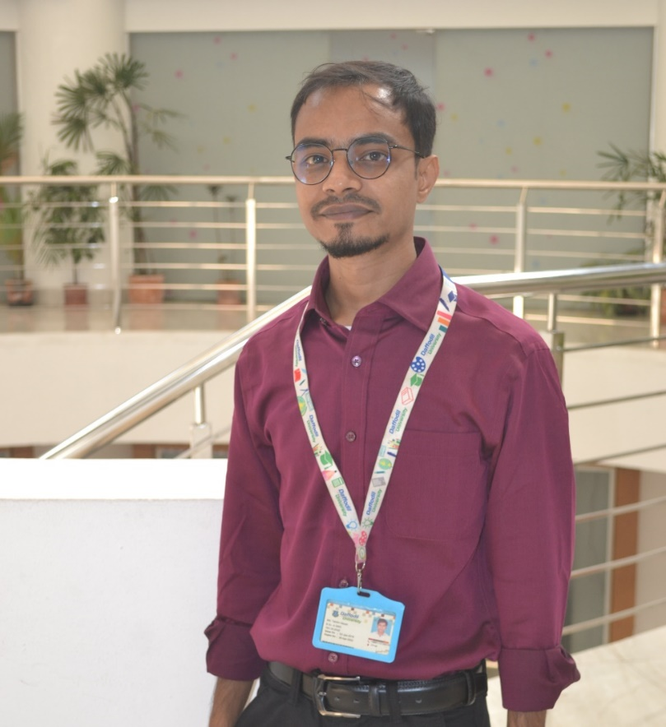

**Figure: 3.2**: Data collecting specific distance and angel.

I use a digital camera and a camera stand one poster board for collect image for my dataset. As a thing to be find them and place them in various positions and orientations over the background, such as flat, dirt, and so on. Another device was tested on the road. Each data set is made up of a number of different brick positions. The figure depicts the various orientations. A view of the rate at which data was gathered. As a material, we close brick. I’m looking for a representation for the ribbon minimum size that I’d like to detect because I’m scanning an object. When an object is smaller than a brick, there are too few return points to effectively identify it. The scale the scan pace and scan factor that limit the number of detected objects.

## 3.3 Image Pre-processing

Improving input data quality for neural reworks can highly contribute to better predication result and higher accuracy, which are the main goal when using any kind of neural networks. Some of the techniques that can be use for image data preprocessing for the purpose of improving input for neural networks are erosion, dilation, opening, closing and super resolution.

Due to the rapid development of mobile devices equipped with cameras, the realization of what you get is what you see is not a dream anymore. In general, texts in images often draw people’s attention due to the following reasons: semantic meaning to object in the image, information about environment or commercial purpose.

Preprocessing is a common name for lowest abstraction level image operations, both input and output are frequently images. Pre-processing is aimed at improving images data which suppresses undesirable defects or improves certain essential images features for future processing. Some pre-processing of the image was performed including noise reduction and filtering before using the images for segmentation. Computerized ribbon image is prone to commotion of various kinds. Clamor is the result of error in image procurement that prepare the result in pixel value that do not reflect the real power of real scene.

Mohammad Naved Qureshi et al.the grayscale image suggested to their channel is a simple type of image containing one domain, and each pixel in the image can be represented by an integer, it only carries knowledge about frequency. We used the built-in method of MATLAB to determine each pixel’s intensity value.

## 3.4 Data Analysis Technique

All images include frequencies of space. In space, the gray level in the image varies. it’s rises and falls. Filtering is a simple method of image processing. We know that high frequencies are passed by a median filter and filter and low frequencies stop. Similarly, in an image, we can filter spatial frequencies. The Median Filer is a non-liner digital filtering technique, often used to eliminate noise from an image or signal. Those noise reductions are a normal pre-processing step in order to improve the performance of later processing.

The median filter is a common way to remove “salt-and-paper” noise from an image while retaining edges and maintaining useful information at the same time. The median filter is used in this paper to preprocess and smooth the images of the source. The formula used as the following:

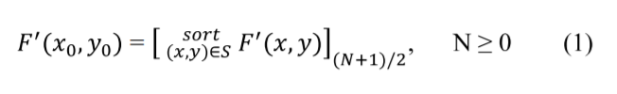

### 3.4.1 Support Vector Machine (SVM)

One of the best and most effective Machine Learning classification algorithms is support vector machine. When the dataset to work with is less, though, support vector machine is more common. This makes sense because we know that as the amount of the dataset grows, the SVM would take longer to train.

Support Vector Machines (SVM) are commonly thought of as a classification strategy, however they may be used to solve both classification and regression problems. It can handle both continuous and categorical variables with ease. To differentiate various classes, SVM creates a hyperplane in multidimensional space. SVM iteratively generates the best hyperplane, which is then utilized to minimize an error. The goal of SVM is to find a maximum marginal hyperplane (MMH) that splits a dataset into classes as evenly as possible.

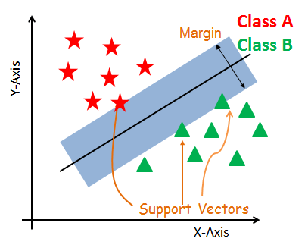

**Figure:3.4.1.1:** Support Vector Machine (SVM) Classification technique

Support vector machine are supervised learning algorithms for the most part. They’re also the best algorithm for classifying data that hasn’t been seen before. As a result, they can be used in wide range of situations.

**Supporting Characteristics**

The data points nearest to the hyperplane are called support vectors. By computing margins, these points will better define the separation line. These points are more relevant to the classifier's construction.

**Hyperplane**

A hyperplane is a decision plane that distinguishes between a group of objects with distinct class memberships.

**Margin**

A margin is the distance between the two lines on the class points that are closest to each other. The perpendicular distance from the line to the support vectors or closest points is determined. A bigger margin between the classes is regarded a good margin, whereas a smaller distance is considered a bad margin.

A support Vector Machine (SVM) is a discriminative classifier with a separating hyperplane as its formal definition. In other word, the algorithm produces an ideal hyperplane that categories fresh sample given labeled trained data (supervised earning). This hyperplane is a line in two-dimension space that divides a plan into two sectors, with each class either side.

Suppose you are given plot of two label classes on graph on as shown in (3.4.1.1). Can you decide a separate line for the classes?

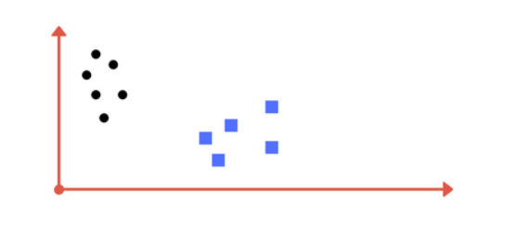

**Figure:3.4.1.2:** Draw a line that separates two classes (black circles and blue squares).

You may have come up with something similar to the image below (figure 3.4.1.2). It effectively divides the two classes. Any location on the left of the line is classified as a black circle, while ay point on the right as classified as a blue square. Class division is a term used describe the separation of classes. SVM accomplishes this. It discovers a line/hyper-plane (in multidimensional space that separate outs classes). We’ll talk about why I wrote multidimensional space in a minute.

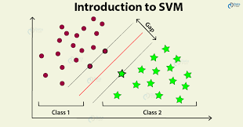

**Figure:3.4.1.3:** Sample cut to divide into two classes

**How does SVM work**

The main goal is to separate the given dataset as efficient as feasible. The margin is the distance between the two points that are closest to each other. The goal is to find a hyperplane that has the largest feasible margin between support vector is the data set. In the following steps, SVM looks for the largest marginal hyperplane:

* Create hyperplanes that effectively depurate the classes. Three hyperplanes black, blue, and orange, are shown on the left side of the illustration. The red and green classes exhibit more classification error, while the black class correctly separates the two classes.

* As illustrated in the right-hand figure, choose the right hyperplane with the highest segregation from the nearest data points.

**Let’s import the necessary libraries:**

1.imort numpy as np

2.Import cv2

3.import pandas as pd

4.import tensorflow as tf

5.from tensorflow.keras.preprocessing.image import ImageDataGenerator

6.from tensorflow.keras import Sequential

7.from tensorFlow.keras.layers import Conv2D,Dense,MaxPool2D,Flatten

8.from tensorflow.keras.regularizers import 12

**Data Augmentation Here:**

1. tarin_dir = “dataset/training_set/”

2.test_dir = “dataset/test_set/”

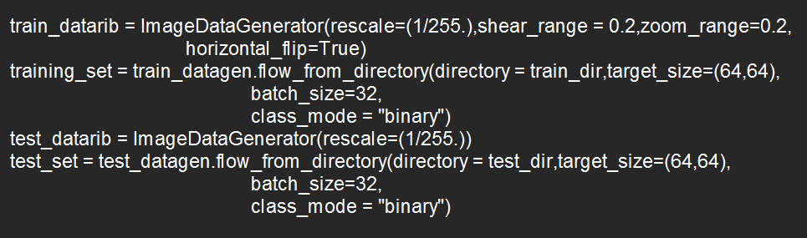 3.

**Model Creation**

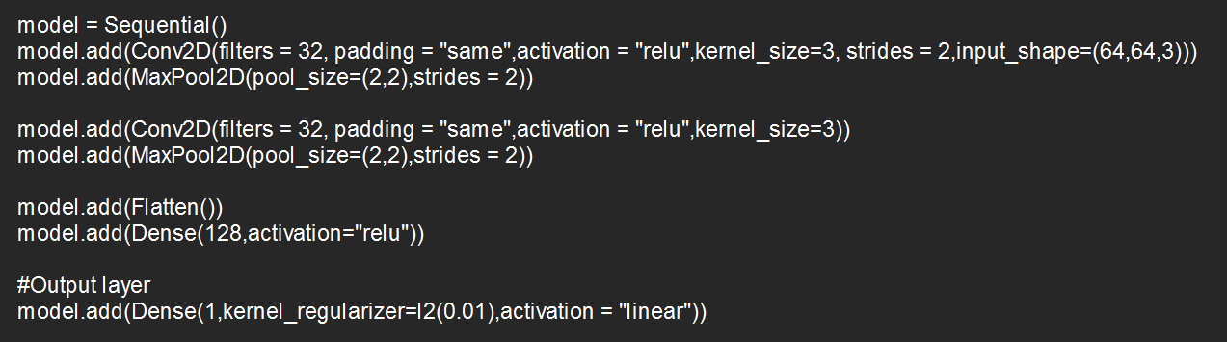

In a typical CNN, we’d write model in the output layer.add (Dense(1,activation = “sigmoid”)) to the equation

But, if we want to convert this to SVM we’ll use to convert this SVM, we’ll use a parameter called “kernel regularize,” and inside this regularized, we’ll use |1 or |2 norm, and pass linear as the activation function, like we did in the final output layer above in the model building section. Because we utilize something called Linear Vector Machine for binary classification. We’ll try to draw a line between them and then discover more margin line before attempting to separate the classes using linear SVM. SoftMax as an activation function for SVM is required for multiclass classification.

**Train Model:**

1. history = model.fit(x=training_set, validation_data = test_set, epoch = 15)

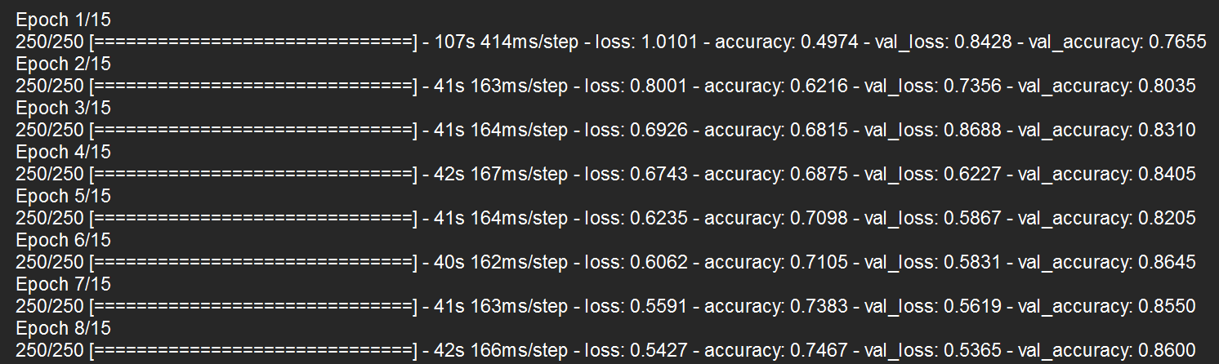

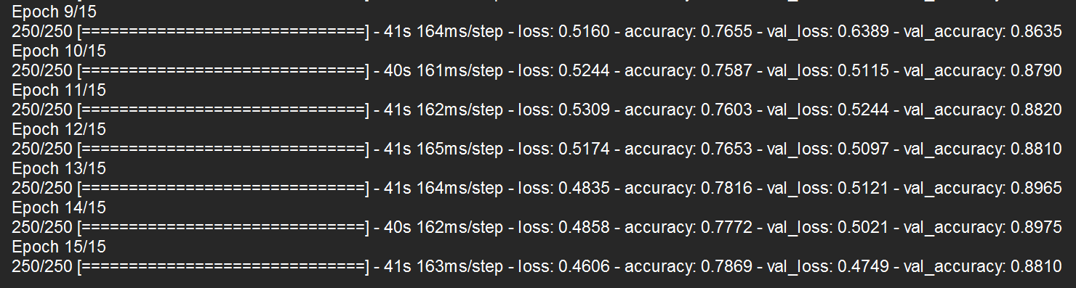

**3.4.2: Histogram Oriented Gradient (HOG)**

HOG (Historical Histogram of Oriented Gradients) is a feature descriptor similar to the Canny Edge Detector and SIFT (Scale Invariant and Feature Transform).

For the goal of object detection, it is employed in computer vision and image processing. The technique counts the number of times a gradient orientation appears in limited area of an image. Edge Orientation Histograms and Scale Invariant a Feature Transformation are two method that are similar (SIFT). The HOG descriptor is concerned with an object’s descriptor is concerned with an object’s structure or from. It outperforms all other edge descriptors because it computers feature based on both the magnitude and angle of the gradient. It creates histograms for the image’s regions based on the gradient magnitude and orientation.

Take the image for which you wish to compute the HOG feature. Resize the image to a 28x6 pixel scale. This dimension was mentioned in the paper as the key goal with this form in the paper as the key goal with this from of education. After achieving near-perfect result in the MIT pedestrian data base, the authors opted to create a new, much more difficult data set dubbed RIBBON which contains more than 200 real images of human clipped from a variety of personal photo.

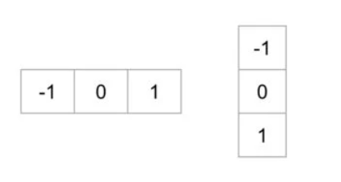To calculate a HOG descriptor, we need to first calculate the horizontal and vertical gradients; after all, we want to calculate the histogram of gradients. This is easily achieved by filtering the image with the kernels.

Notice, the x-gradient fires on vertical lines and the y-slope fires on even lines. The greatness of slope fires any place there is a sharp change in force. Not a single one of them fire when the district is smooth. I have purposely left out the picture showing the bearing of angle since heading displayed as a picture doesn’t pass on a lot. The angle picture eliminated a ton of unnecessary data (for example consistent shaded foundation), however feature blueprints. As such, you can take a gender at the inclination picture and still effectively say there is an individual in the image.

The image is divided into 8x8 cell in this step, and histogram of slopes is calculated for each 8x8 cell. We’ll get to the histogram in a minute, but first let’s understand why we divided the image into 8x8 cell in the first place. One of the most compelling reasons to use an element descriptor to depict a place of a picture is that it provides a more accurate portrayal 8x8x3 = 192-pixel esteems are contained in an 8x8 picture repair. This fix’s inclination has to attribute every pixel totaling 8x8x2= 128 value.

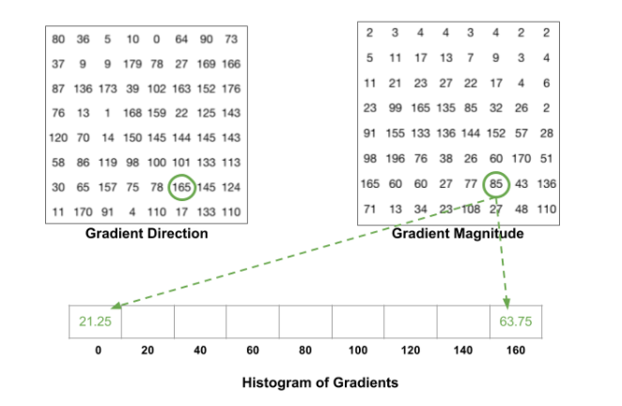Before the finish of this part er will perceive how these 128 numbers are addressed utilizing a 9-receptacle histogram which can be put away as a variety of 9 numbers. Not exclusively is the portrayal smaller, working out a histogram over a fix makes this representation stronger to

**Figure:3.4.2.1:** 3 Histogram of Gradients

commotion. Individual gradients may have commotion, however a histogram over 8x8 fix makes the portrayal significantly less touchy to clamor.

Yet, why 8x8 fix? why not 32x32 ? It is a plan decision informed by the size of highlights we are searching for. Hoard was utilized for passerby discovery at first, 8x8 cell in a photograph of a passerby scaled to 64x128 are adequately large to catch fascinating highlights.

The commitment of the relative multitube of pixel in the 8x8 cells are amounted to make the 9-container histogram. For the fix above, it resembles this

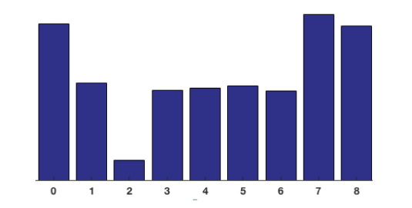

**Figure 3.4.2.2:** 4 Histogram of a cell

In our portrayal, the y-hub is 0 degrees. You can see the histogram has a ton of weight close to 0 and 180 degrees, which is simply one more method of saying that in the fix inclinations are pointing either up or down.

In the past advance, we made a histogram dependent on the angle of the picture. Slopes of a picture are delicate to by and large lighting. On the off chance that you make the picture hazier by isolating all pixel esteems by 2, the inclination size will change considerably, and accordingly the histogram esteems will change significantly.

In a perfect world, we need our descriptor to be free of lighting varieties. All in all, we might want to "standardize" the histogram so they are not impacted by lighting varieties. Before I clarify how the histogram is standardized, we should perceive how a vector of length 3 is standardized.

Suppose we have a RGB shading vector [ 128, 64, 32 ]. The length of this vector is $\sqrt {128^2 + 64^2 + 32^2} = 146.64$. This is additionally called the L2 standard of the vector. Separating every component of this vector by 146.64 gives us a standardized vector [0.87, 0.43, 0.22].

Presently consider one more vector in which the components are double the worth of the principal vector 2 x [ 128, 64, 32 ] = [ 256, 128, 64 ]. You can resolve it yourself to see that normalizing [ 256, 128, 64 ] will result in [0.87, 0.43, 0.22], which is as old as standardized adaptation of the first RGB vector. You can see that normalizing a vector eliminates the scale.

Since we know how to standardize a vector, you might be enticed to believe that while ascertaining HOG you can essentially standardize the 9x1 histogram the same way we standardize the 3x1 vector above. It’s anything but an impractical notion, however a superior though is to standardize over a greater measured square of 16x16. A 16x16 square has 4 histograms which can be linked to frame a 36x1 component vector and it tends to be standardized only the manner in which a 3x1 vector is standardized. The windows are than mover by 8 pixels and standardized 36x1 vector is determined over this window and the interaction is rehashed.

To work out the last component vector for the whole picture fix, the 36x1 vectors are connected into one goliath vector. The number of places of the 16x16 squares do we have? There are 7 level and 15 vertical positions making an aggregate of 7x15=1.5 positions. Each 16x16 square is addressed by a 36x1 vector. So, when we connect then all into one giant vector, we get a 36x105=3780 layered vector.

The HOG descriptor of a picture fix is generally envisioned by plotting the 9×1 standardized histograms in the 8×8 cells. See picture as an afterthought. You will see that predominant course of the histogram catches the state of the individual, particularly around the middle and legs. The last element vector of Histogram of Oriented Gradients will be determined by the link of element vectors of all squares in a picture. Along these lines, eventually, we will get a monster vector of elements.

Also, this is the means by which highlights of a picture are determined utilizing HOG. There are numerous techniques for include extraction yet this concentrates highlights utilizing the angle which makes it not quite the same as others.

**3.4.3: YOLO**

Consequences be damned is a shortened from for the term “You Only Look Once”. This is a calculation that identifies and perceives different articles in an image (progressively). Object recognition is YOLO is done as a replace issue and given the class probabilities of the distinguished pictures.

Consequences be damned calculation utilizes convolutional neural organizations (CNN) to identify object progressively. As the name recommends, the calculation requires just a solitary forward proliferation through a neural organization to identify objects. This implies that forecast in the whole picture is done in a solitary calculation run. The CNN is utilized to foresee different class probabilities and bouncing boxes all the while. The YOLO calculation comprises of different variations. A portion of the normal ones incorporate small YOLO.

**Why the YOLO algorithm is important:**

YOLO algorithm is important because of the following reasons:

**Speed:** This algorithm improves the speed of detection because it can predict object in real-time.

**High Accuracy:** YOLO is a predictive technique that provides accurate result with minimal background errors.

**Learning Capabilities:** The algorithm has excellent learning capabilities that enable it to learn the representations of object and apply them in object detection.

How the YOLO calculation functions:

Just go for its calculation works utilized the accompanying three methods:

* Leftover squares

*Jumping box relapse

*Crossing Points Over Union (IOU)

**Residual blocks:**

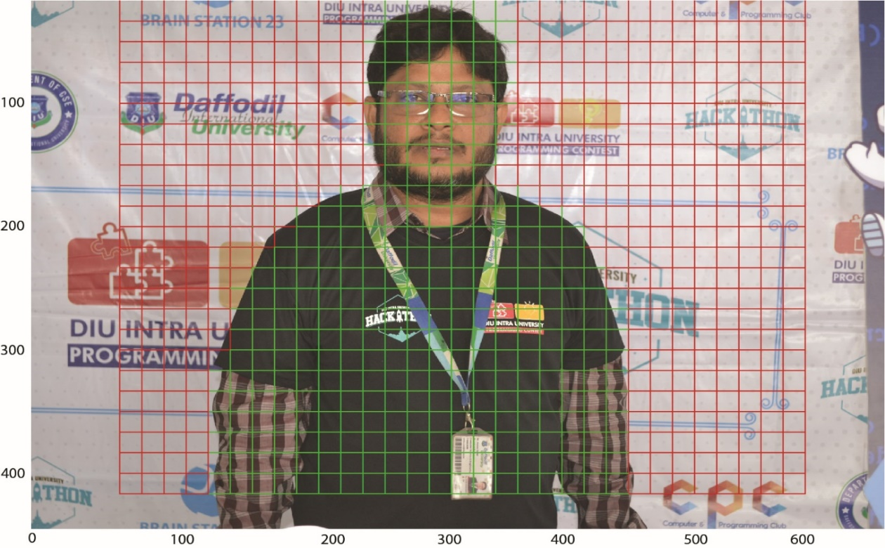In the first place, the picture is separated into different networks. Every matrix has an element of SxS. The accompanying picture shows how an information picture is separated into networks. In the picture above, there are numerous framework cells of equivalent aspect. Each framework cell will recognize object that show up inside them. For instance, assuming that an article community show up inside a specific framework cell, then, at that point, this cell will be liable for identifying it.

**Figure-3.5.2:** Input image divided into grid

**Bounding box regression:**

A bounding box is an outline that highlights an object in an image. Every bounding box in the image consists of the following:

* Width

*Height

*Class (for example, person, car, traffic, light, etc.)- This is represented by the letter.

*Bounding box center

The flowing image shows an example of a bounding box. The bounding box has been represented by a yellow outline.

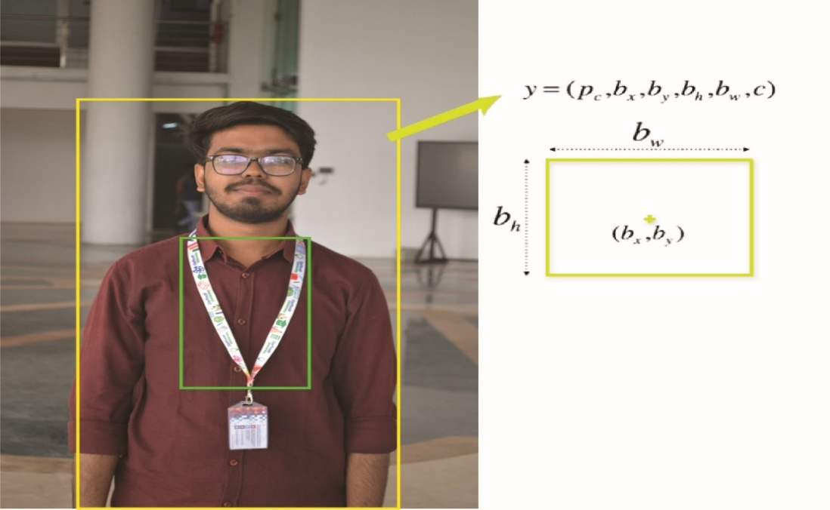

**Figure 3.5.3:** The bounding Box (YOLO)

YOLO uses a single bounding box regression to predict the height, width, center and class of object. In the image above, represents the probability of an object appearing in the bounding box.

**Crossing Points Over Union (IOU):**

Convergence over association (IOU) is a peculiarity in object identification that portrays how boxes cross-over. Consequences be damned uses IOU to give a result box that encompasses the items impeccably.

Every network cell is liable for anticipating the jumping boxes and their certainty scores. The IOU is equivalent to 1 if the anticipated bouncing box is as old as genuine box. This instrument wipes out bouncing boxes that are not equivalent to the genuine box.

The accompanying picture gives a basic illustration of how IOU functions. In the picture above, there are two bouncing boxes, one in green and the other one in blue. The blue box is the anticipated box while the green box is the genuine box. Just go for it guarantees that the two bouncing boxes are equivalent.

**Application of YOLO:**

Just go for it calculation can be applied in the accompanying fields:

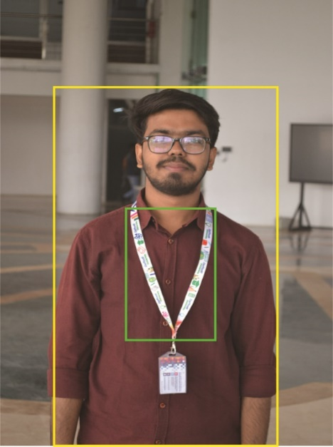Independent driving: YOLO calculation can be utilized in independent vehicles to distinguish object around vehicles like vehicles, individuals, and leaving signals. Object location in independent vehicles is done to stay away from impact since on human driver is controlling the vehicle.

**Figure 3.5.4:** The sample work of IOU (YOLO)

Natural Life: This calculation in utilized to distinguish different sorts of creatures in timberlands. This sort of recognition is utilized by natural life officers and writers to distinguish creatures in recordings and pictures. A portion of the creatures that can be recognized incorporate giraffes, elephants, and bays.

Security: YOLO can likewise be utilized in security frameworks to uphold security in a space. How about we accept that individuals have been limited from going through a specific region for the sake of security. Assuming that somebody goes through that limited region, the YOLO calculation will identify him/her, which will require the security work force to make a further move.

## 3.5 Summary

To carry out my plan, I had to give TensorFlow assistance. TensorFlow is an incredibly important requirement for upgrading my entire undertaking. TensorFlow makes my job easy to do. It’s the most precondition for me to do my business, making my work simpler and welcoming my client to everyone. I’m using the TensorFlow library here. Because it has all the overhauled offices to do the job and I used this application exceptionally well.

# CHAPTER 4

# RESULTS AND DISCUSSION

The raw picture was first gathered and captured to get the final result from different images, member was wearing. To induce the ultimate result, it was collected and captured from various ranches and shape to begin with the crude pictures. The most prepared dataset was arranged after the information was pre-processed. The ultimate result appeared as the recognized lesson at long the test image in compared to the dataset using multi-class vector machine. I use TensorFlow to set up and find the result of my experiments. Because using TensorFlow, getting all the result is very easy.

## 4.1 Experimental result:

We can see that detection area detection based on Support Vector Machine and Histogram Oriented Gradient and YOLO (You Only Look Once) according to visual inspection. Growing in the region yields better results than other approaches. However, The SVM method is better than other since it is used to separate the images background. We have manually extracted the ground reality using Adobe Photoshop, a tool for the image processing.

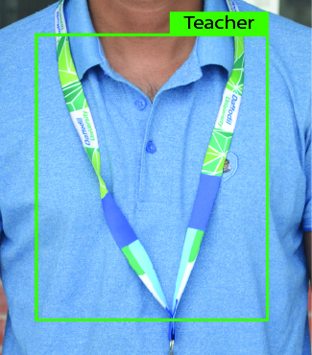

Output: Teacher

Accuracy 90%

**Figure 4.1.1:** Output of Teacher.jpg

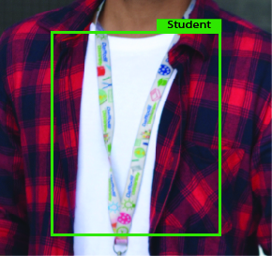

Output: Student.jpg

Accuracy: 90%

**Figure 4.1.2:** Output of Student.jpg

### 4.1.1 Descriptive Analysis.

To encourage the correct execution of my entire exploration requirement, I thought to start with planning the shape details of distinctive nearby natural products. Since my goal is to identify the shape to distinguish shape of various kinds of natural products. I orchestrated different ribbon in the neighborhood. I captured part of pictures for my test, but I used 10 pictures for the comfort of my test. I sectioned those pictures at that point using distinctive segmentation kinds.

Here I use different techniques to detection ribbon. I also use method for noise remove, filtering to extract dataset characteristics.

Finally, the detection of ribbon anticipated will be pointed on the screen. After that the final result image appeared.

### 4.1.2 Summary

Ribbon detection would be a new look for security and it play a very important role in their institute as well. I use daffodil international University ribbon for identify student and teacher separately. And also important for transport system as usually student suffer to ware their on-campus bus. Using this system Bus can automatically find the student and Faculty as well.

This will inform automatically which one is faculty and which one is student. And which one is another stage member. It would be nice for our campus. And also, good enough for our security or gate man duty. It automatically open when system find a ribbon as like his train data set.

# CHAPTER 5

# CONCLUSIONS AND RECOMMENDATIONS

## 5.1 Findings and Contributions

I have collected images data from different various location in this inquiry. The natural product of the neighborhood is captured at the pint and the pictures captured prepared for processing. The images are shifted in pre-processing. In additional, the strategy of expulsion from clamor is connected here. I use Support Vector Machine (SVM) and Histogram Oriented Gradient (HOG) for image classification preprocessing arrangement. I’ve done all the division. And using those division out last aim is to detect the ribbon from image. Everyone can easily detect and recognize the different type of ribbon using my project by first detecting their shape.

In this paper, I present a mythology based on a combination of Support Vector Machine (SVM) and histogram Oriented Gradient (HOG) of experiment purposes, 200 hundred images include ribbon families were regraded, from which only 50 ribbon pictures are picked. I concentrate my work on classification and detection real time image. In this research, ribbon are segmented by image processing methods that can be used to segment any ribbon that can open a door to support local people and institute gate pass and also transport system. Although there were some obstacles when working, the background color and poor quality of the image that distract the application in order to produce more result.

The whole process is conducted with more than 90 % accuracy using pictures taken from different angle of ribbon.

## 5.2 Recommendations for Future Works

A few natural product identification techniques were created based on the properties g color and shape. Nevertheless, distinguishing natural product image may have equivalent or identical value of color and shape. Subsequently, using color highlights and shape highlights analysis strategies are not yet robust and effective enough to identify and recognize natural product pictures, an unused natural product recognition system has been suggested, incorporating three highlights examination strategies: color, dependent, grayscale, size based in order in to extend acknowledgement precision. By using the closet neighbor classification, the proposed strategy classifies and recognizes natural product images based on obtained highlight value. This system then appears to the consumer as the natural product name and brief and description. The proposed model inquiry for the classification of natural product classifies and efficiently identifies up to 90% accuracy of ribbon detect. In a variety of areas such as teaching, picture recovery any manor science, this system often acts as a valuable tool.

To make our life easy and less challenging, we are constantly becoming exceptionally subordinate to the advance of the present day, where in our country, the division of security is use to from using different kind of advance technology, which can be a matter of flourishing at a significant rate. The suggested model tends to be a better approach to the machine learning technique that can classify and recognize the distinctive forms of natural products. To efficiently hit the root level ranchers, this method can be adapted into ant form of portable software or web-based application. People directly send the capture picture from the arrival and get the yield hand in a moment when the title of ribbon is.

# REFERENCES

Ahmad T, Ma Y, Yahya M, Ahmad B, Nazir S. Object detection through modifed YOLO neural network. Scientifc Programming, 2020

A.J. Lipton, H. Fuijiyoshi, R.S Patil. Moving target classification and tracking from real-time video. Proceedings of the IEEE Workshop on Application of Computer Vision, 1998, 8-14

Chen, C. and Tian, Y. (2010) ‘Door detection via signage context-based hierarchical compositional model’, Computer Vision and Pattern Recognition Workshop, pp.1–6.

Comaschi, F., Stuijk, S., Basten, T. and Corporaal, H. (2013) ‘RASW: a run-time adaptive sliding window to improve Viola-Jones object detection’, Proceedings of Seventh International Conference on Distributed Smart Cameras (ICDSC), 2013, pp.1–6, 29 October to 1 November, doi: 10.1109/ICDSC.2013.6778224.

Chen W, Huang H, Peng S, Zhou C, Zhang C. YOLO-face: a real-time face detector. The Visual Computer 2020:1–9.

Ding S, Zhao K. Research on daily objects detection based on deep neural network. IOP Conf Ser Mater Sci Eng. 2018;322(6):062024

Elbouz, M., Ayman, A. and Brosseau, C. (2011) ‘Fuzzy logic and optical correlation-based face recognition method for patient monitoring application in home video surveillance’, Optical Engineering, Vol. 50, No. 6, pp.1–13

Galleguillos, C. and Belongie, S. (2010) ‘Context based object categorization: a critical survey’, Computer Vision and Image Understanding, Vol. 114, No. 6, pp.712–722.

GE, J. and Luo, Y. (2009) ‘A comprehensive study for asymmetric AdaBoost and its application in object detection’, Journal of Acta Automatica Sinica, Vol. 35, No. 11, pp.1403–1409.

Gepperth, A., Dittes, B. and Ortiz, M.G. (2012) ‘the contribution of context information: a case study of object recognition in an intelligent car’, Journal on Neurocomputing, Vol. 94, No. 1, pp.77–86, doi: 10.1016/j.neucom.2012.03.008.

Gualdi, G., Prati, A. and Cucchiara, R. (2011) ‘Multi-stage particle windows for fast and accurate object detection’, IEEE Transactions on Pattern Analysis and Machine Intelligence, Vol. 34, No. 8, pp.1589–1604.

Gunduz-Demir, C., Kandemir, M., Tosun, A.B. and Sokmensuer, C. (2010) ‘Automatic segmentation of colon glands using object-graphs’, Medical Image Analysis, Vol. 14, No. 1, pp.1–12.

Girshick, Ross, et al. "Rich feature hierarchies for accurate object detection and semantic segmentation." Proceedings of the IEEE conference on computer vision and pattern recognition. 2014

Hori, T., Takiguchi, T. and Ariki, Y. (2012) ‘Generic object recognition by graph structural expression’, ICASSP, pp.1021–1024.

Hinton, Geoffrey E., et al. "Improving neural networks by preventing co-adaptation of feature detectors." arXiv preprint arXiv:1207.0580 (2012).

Hussin, R., Juhari, M.R., Kang, N.W., Ismail, R.C. and Kamarudin, A. (2012) ‘Digital image processing techniques for object detection from complex background image’, in International Symposium on Robotics and Intelligent Sensors, Vol. 41, pp.340–344.

Karasulu, B. (2010) ‘Review and evaluation of well-known methods for moving object detection and tracking videos’, Journal of Aeronautics and Space Technologies, Vol. 4, No. 4, pp.11–22.

Kim, J., Kim, M., Lee, S., Oh, J., Oh, S. and Yoo, H. (2009) ‘Real-time object recognition with neuro-fuzzy controlled workload-aware task pipelining’, Micro, IEEE, Vol. 29, No. 6, pp.28–43.

Kim C, Lee J, Han T, Kim YM. A hybrid framework combining background subtraction and deep neural networks for rapid person detection. J Big Data. 2018;5(1):22

Krizhevsky, Alex, Ilya Sutskever, and Geoffrey E. Hinton. "Imagenet classification with deep convolutional neural networks." Advances in neural information processing systems. 2012.

Kontschieder, P., Bul, S., Criminisi, A., Kohli, P., Pelillo, M. and Bischof, H. (2012) ‘Context-sensitive decision forests for object detection’, Proceedings on Advances in Neural Information Processing Systems.

Khan, Fahad Shahbaz, et al. "Color attributes for object detection." Computer Vision and Pattern Recognition (CVPR), 2012 IEEE Conference on. IEEE, 2012.

Liang, Z., Chi, Z., Fu, H. and Feng, D. (2012) ‘Salient object detection using context sensitive hyper graph representation and partitioning’, Pattern Recognition, Vol. 45, No. 11, pp.3886–3901.

Liu, Y., Wu, Y. and Yuan, Z. (2011) ‘Object detection using discriminative photogrammetric context’, International Conference on Image Processing, pp.2405–2408.

Lopes, N.V., Couto, P., Jurio, A. and Melo-Pinto, P. (2013) ‘Hierarchical fuzzy logic-based approach for object tracking’, Knowledge-Based Systems, Vol. 54, No. 1, pp.255–268, doi: 10.1016/j.knosys.2013.09.014.

Madaan, T. and Sharma, H. (2012) ‘Object detection in remote sensing images: a review’, IJSRP, Vol. 2, No. 6, pp.1–3.

Manoranjan Paul, Shah M E Haque and Subrata Chakraborty. Human detection in surveillance videos and its applications - a review. EURASIP Journal on Advances in Signal Processing 2013, 2013:176

Mittal P, Sharma A, Singh R. Deep learning-based object detection in low-altitude UAV datasets: a survey. Image and Vision Computing 2020:104046.

Segvic, S., Kalafatic, Z. and Kovaˇcek, I. (2011) ‘Sliding window object detection without spatial clustering of raw detection responses’, Proceedings of the Computer Vision Winter Workshop.

Sun, M., Bao, S. and Savarese, S. (2012) ‘Object detection with geometrical context feedback loop’, IJCV, Vol. 100, No. 2, pp.154–169.

Suna, Z., Bebisa, G. and Millerb, R. (2011) ‘Object detection using feature subset selection’, 18th IEEE International Conference on Image Processing, Vol. 37, pp.2165–2176.

Shrey Srivastava* , Amit Vishvas Divekar, Chandu Anilkumar, Ishika Naik, Ved Kulkarni and V. Pattabiraman(2021) “Comparative analysis of deep learning image detection algorithms”,Object detection, FRCNN,YOLO-v3,SSD,COCO Dataset

S. Manjula and Dr.K.Lakshmi (2016) “A STUDY OF OBJECT DETECTION”, Object Detection, Object Classification, Motion Segmentation

Sandeep Kumar, Aman Balyan, Manvi Chawla (2017)” Object Detection and Recognition in Images”, Computer vision and Feature Extraction.

Ren, Shaoqing, et al. "Faster R-CNN: Towards real-time object detection with region proposal networks." Advances in neural information processing systems. 2015

Ren S, He K, Girshick R, Sun J. Faster r-CNN: Towards real-time object detection with region proposal networks. IEEE Trans Pattern Anal Mach Intell. 2016;39(6):1137–49.

Redmon, Joseph, et al. "You only look once: Unified, real-time object detection." Proceedings of the IEEE Conference on Computer Vision and Pattern Recognition.2016.

Redmon J, Divvala S, Girshick R, Farhadi A. You only look once: Unifed, real-time object detection. In: Proceedings of the IEEE conference on computer vision and pattern recognition; 2016, pp. 779–788.

Z Lin, LS Davis. Shape-based human detection and segmentation via hierarchical part-template matching. IEEE Trans. Pattern Anal. Mach. Intell.32(4), 604–618 (2010).

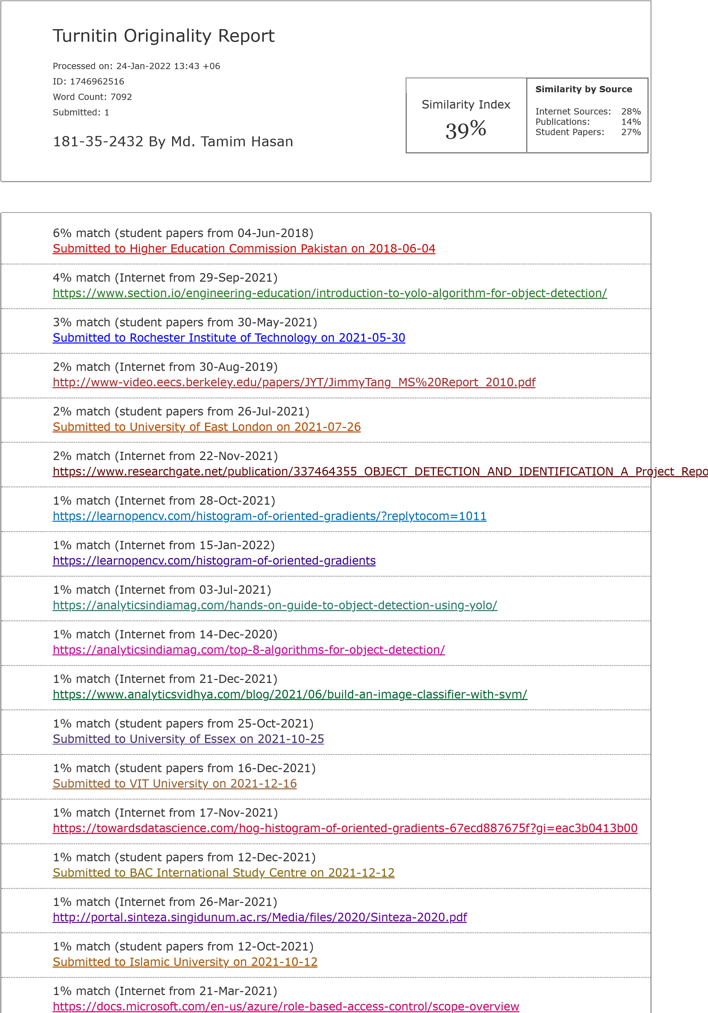**Plagiarism Report:**

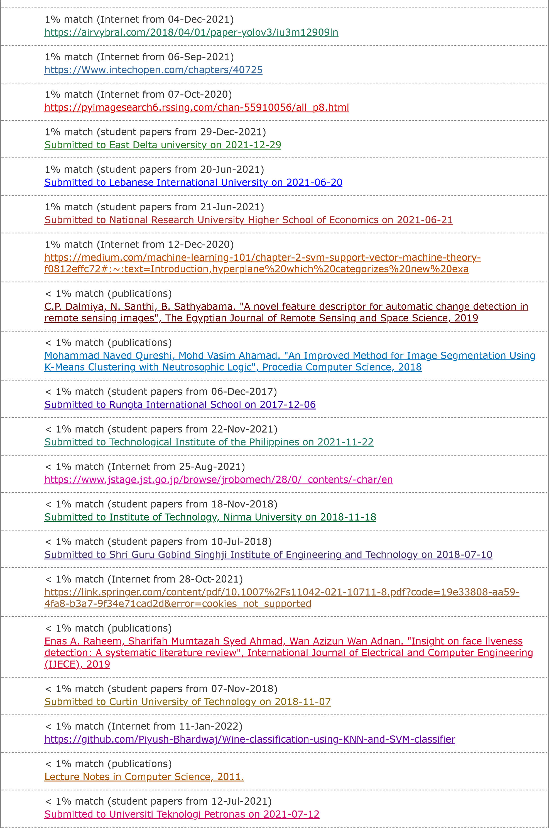

CHAPTER 1 INTRODUCTION 1.1 Background The value of computer vision object detection is rising day by day. Object detection in one of the most important and difficult problem in image analysis. Digital image process plays an excellent trip in day-by-day life application like natural picture, medical pictures, satellite pictures and the fourth. Image detection could be a vintage subject within the field of image process and is also a hotspot and hub of image processing technique. Detection of image is an important part of processing of images. Detection of the fluctuated segment among the particles is to an excellent degree crucial to restorative decision. The method of partitioning an image into relevant region or artifact in computer vision image detection. Detection has a range of strategies like: Edge detection- this technique distinguished the edge and identifies the boundaries in an object. It is a special approach used for detection the edges. That attempts to capture artifact’s significant properties in the picture, Region Growing- building pixels into larger region based on predefined seed pixels, growing parameters and stopping condition, YOLO, a new approach to object detection. Prior work on object detection repurposes classifiers to perform detection. Instead, object detection as a regression problem to spatially separated bounding boxes and associated class probabilities. A single neural network predicts bounding boxes and class probabilities directly from full images on an environment. YOLO model processes images in real time at 45 frames per second. A smaller version of the network, Fast YOLO, processes an astounding 155 frames per sound while still achieving double the mAP of other real time detectors. Using the algorithm, theobject detector an input image int an SxS grid where each cell in the grid predicts only a single object. If there exist multiple, small object in single cell then YOLO will be unable to detect them, ultimately leading the missed object detection. In my case the recognizable proof is still a challenging assignment due to assortment of shape, color of design in ribbons, changeability of deformity sorts and nearness of stem and so on. Object recognition is a term that refers to a group of tasks that are used to recognize things in digital pictures. R-CNNs, or Region-based Convolutional Neural Networks, are a set of algorithms for solving object recognition and localization tasks that are optimized for model performance. You Only Look Once, or YOLO, is the second family of object identification systems that are designed for speed and real-time use. 1.2 Motivation of the Research Image detection is a very important topic in present era. In deep learning there are many significant works about image detection. Not only object detection topic it also very important role in security also. In this topic Ribbon detection is very important topic for security also. This idea is use for detect an identity as well as also use for security also. The motive of object detection is to recognize and local all know object in a scene like daffodil ribbon. There are many kinds of ribbon available in different university. But this paper is just for Daffodil International University. Object detection can help to improve the security system in private sector. Camera can use computer vision to monitor the territory and uninvited guest at night. With the inclusion of identification technologies in the system, it can also determine the personality of the person. 1.3 Objective The aims of this research are to find out and analysis a technique that can help separate local student or teacher ribbon and thus make an appropriate result. The propose system is user- friendly, easy to execute and can be easily implemented in any process. > To show to our university visitor the local ribbon. > To make the people of our unitarity conscious of our all member. > To contribute to our country’s research field. > To make a security process by ribbon. >To use technique for segmenting images. 1.4 Research Scope Scope is the set of resources that access applies to. When I assign a role, it’s important to understand scope so that everyone can grant a security principle just the access that it really need. By limiting the scope, you limit what resources are at risk if the security principle is ever compromised. Object recognition is a term that refers to a group of tasks that are used to recognize things is digital picture. R-CNNs, or Region-based Convolutional Neural Networks, are a set of algorithms for solving object recognition and localization tasks that are optimized for model performance. You Only Look Once, or YOLO, is the second family of object identification system that are designed for speed and real time use. In future this paper adds some new feature like add more different kind of ribbon for detection. Daffodil can use this use this technique for security purpose. Not only daffodil this technique can uses for every security step. 1.5 Thesis Organization Ribbon is a important part of security sector. It would be very strong part of security sector. In the main gate or entry option it would a very strong part. Anyone who don’t have their id they can’t entry in their organization. Other hand we though to know about the ribbon in different sector member. And in this work in this project. We thought of method that will open to the youth society by taking photo to identify the ribbon. For this problem we need to classifier system. In classifier system we need to do image processing like segmentation. My proposed system I will try to investigate different technique for find the better result. 1. I will get a research-based project (There is no work on ribbon detection system in our country util now. I believe that lot of information will come out in this research) 2. Can know about different ribbon (This system not only detect ribbon but also provided information about different ribbon) 3. Know about Daffodil different label staff ribbon not only staff but also student also. 3. Show the new detection system to future generations and country. CHAPTER 2 LITERATURE REVIEW 2.1 Background In this sector, several studies carried out by researchers in the field of image segmentation, ribbon detection, image categorization, image detection, classification in addressed. Different research work that is actually done relate this image detection field. Object detection is an important test, yet challenging vision test. It is a critical part of many applications such as image search, image

auto-annotation and scene understanding, object tracking. Moving object tracking of video image sequence was one of the most important subjects in computer vision. It had already been applied in many computers vision fields, such as smart video surveillance (Arun Hampapur 2005), Artificial intelligence, military guidance, safety detection andsingle-object tracking system appeared, but in the presence of several object, object detection becomes difficult and when object is fully or partially occluded, her are obtruded from the human vison which further increases the problem of detection. Image processing is the most important weapon for analysis in various sector in security science. Image processing now has excellent performance for a few days to find more accurate fields of work. Nevertheless, most of our organization are not aware of modern technology. In order to produce more useful tolls in better way, they must acquire the expertise. And here the processing of image is very useful process. Image processing is not only used for segmentation of ribbon images, but also for detection, classification, texture, color, etc. of ribbon detection. The propose system is capable of studying various segmentation on images of different type of ribbon. Many researches are discussion various algorithms using several techniques. TensorFlow, OpenCV, MATLAB is mainly used in this work for implementation. MATLAB is a program is which image

processing algorithms can be easily implemented. YOLO is a clever convolutional neural network (CNN) for doing object detection in real-time. This is one of these popular object detection methods. In this paper, will learn how to detect object present in the images. For the detection of objects, will use the YOLO (You Only Look once) algorithm and demonstrate this task on a few images. 2.2 Literature Review In this sector, we’re going introduce brief studies on our work. After examining a number of terms paper, we found crucial information to raise out expand thought. Here is the review of those paper- CHAPTER 3 RESEARCH METHODOLOGY 3.1 Introduction To investigate different type of detection technique I use four segmentation algorithms in my project. Before detection first I crop the image also remove image noise and after then filter the stored image. After pre-processing I segmented the captured real-time image. Fig:3.1 shows the overall process of my entire project shows it sequentially. I don’t use here any classifier I use binary classification to find out the region of interest of different type of ribbon. Acquisition Device (Sensor) Pre-Processing Feature Extension Trained Data Classification Decision (Live/Fake) Figure 3.1: Block diagram for segmentation different kind of ribbon. Figure 3.1 Illustrates the working of proposed system. A machine learning framework is required to implement such a machine vision application as defined in this inquiry. The statistical closeness of our work include most natural products from the neighborhood thar are collected from various sources using drastic gadgets such as camera or mobile phone. I have two different ways discovering their shape after receiving those anticipated picture. Pre-processing and separation are the two specific ways. I shift the picture in preprocessing organize and make it clamor free when I get various picture. 3.2 Data Collection Procedure In this paper I want a data set for check performance for this technique. I had to make some real time ribbon pic for this research paper. Actually, data set is verry important for this king of project-based research work. This data set was collected under sunny condition with a Digital camera forward-looking on the font of the person, 1 meter above the ground with 0- 25degree angle downwards as show in figure 3.2.1. This particular technique of auto Sutter support up to a 180-degree field-of-view, a measurement regulation and a maximum scan range of 80 meters. In my data collection I use only a single scanner operating at 75 Hz with a 90degree field of view. Figure: 3.2: Data collecting specific distance and angel. I use a digital camera and a camera stand one poster board for collect image for my dataset. As object to be detect and lay them in various positions and orientation throughout background like flat, dirt test road another object. Each data set corresponds to a combination of brick locations and orientations show in figure. A view of the pace where data was collected. We chose bricks as a representation for the minimum size limit of ribbon thar I wish to detect because scanning an object smaller than a bricks results in too few return points to be detected accurately. The size limitations of detectable object are related to scan rate, scan point regulation within a scan. 3.3 Image Pre-processing Improving input data quality for neural reworks can highly contribute to better predication result and higher accuracy, which are the main goal when using any kind of neural networks. Some of the techniques that can be use for image data preprocessing for the purpose of improving input for neural networks are erosion, dilation, opening, closing and super resolution. Due to the rapid development of mobile devices equipped with cameras, the realization of what you get is what you see is not a dream anymore. In general, texts in images often draw people’s attention due to the following reasons: semantic meaning to object in the image, information about environment or commercial purpose. Preprocessing is a common name for lowest abstraction level image operations, both input and output are frequently images. Preprocessing is aimed at improving images data which suppresses undesirable defects or improves certain essential images features for future processing. Some pre-processing of the image was performed including noise reduction and filtering before using the images for segmentation. Computerized ribbon image is prone to commotion of various kinds. Clamor is the result of error in image procurement that prepare the result in pixel value that do not reflect the real power of real scene. Mohammad Naved Qureshi et al.the grayscale image suggested to their channel is a simple type of image containing one domain, and each pixel in the image can be represented by

an integer [0,255] i.e., it only carries knowledge about frequency. We used the built-in method of MATLAB to determine each pixel’s intensity value. 3.4 Data Analysis Technique All images include frequencies of space. In space, the gray level in the image varies. it’s rises and falls. Filtering is a simple method of image processing. We know that high frequencies are passed by a median filter and filter and low frequencies stop. Similarly, in an image, we can filter spatial frequencies. The Median Filer is a non-liner digital filtering technique, often used to eliminate noise from an image or signal. Those noise reductions are a normal pre-processing step in order to improve the performance of later processing. The median filter is a common way to remove “salt-and-paper” noise from an image while retaining edges and maintaining useful information at the same time. The median filter is used in this paper to preprocess and smooth the images of the source. The formula used as the following: 3.4.1 Support Vector Machine (SVM) One of the best and most effective Machine Learning classification algorithms is support vector machine. When the dataset to work with is less, though, support vector machine is more common. This makes sense because we know that as the amount of the dataset grows, the SVM would take longer to train. Support Vector Machines (SVM) are commonly thought of as a classification strategy, however they may be used to solve both classification and regression problems. It can handle both continuous and categorical variables with ease. To differentiate various classes, SVM creates a hyperplane in multidimensional space. SVM iteratively generates the best hyperplane, which is then utilized to minimize an error. The goal of SVM is to find a maximum marginal hyperplane (MMH) that splits a dataset into classes as evenly as possible. Figure:3.4.1.1: Support Vector Machine (SVM) Classification technique Support vector machine are supervised learning algorithms for the most part. They’re also the best algorithm for classifying data that hasn’t been seen before. As a result, they can be used in wide range of situations. Supporting Characteristics The data points nearest to the hyperplane are called support vectors. By computing margins, these points will better define the separation line. These points are more relevant to the classifier's construction. Hyperplane A hyperplane is a decision plane that distinguishes between a group of objects with distinct class memberships. MarginA margin is the distance between the two lines on the class points that are closest to each other. The perpendicular distance from the line to the support vectors or closest points is determined. A bigger margin between the classes is regarded a good margin, whereas a smaller distance is considered a bad margin. A support Vector Machine (SVM) is a discriminative classifier with a separating hyperplane as its formal definition. In other word, the algorithm produces an ideal hyperplane that categories fresh sample given labeled trained data (supervised earning). This hyperplane is a line in two-dimension space that divides a plan into two sectors, with each class either side. Suppose you are given plot of two label classes on graph on as shown in (3.4.1.1). Can you decide a separate line for the classes? Figure:3.4.1.2: Draw a line that separates two classes (black circles and blue squares). You may have come up with something similar to the image below (figure 3.4.1.2). It effectively divides the two classes. Any location on the left of the line is classified as a black circle, while ay point on the right as classified as a blue square. Class division is a term used describe the separation of classes. SVM accomplishes this. It discovers a line/hyper-plane (in multidimensional space that separate outs classes). We’ll talk about why I wrote multidimensional space in a minute. Figure:3.4.1.3: Sample cut to divide into two classes How does SVM work The main goal is to separate the given dataset as efficient as feasible. The margin is the distance



between the two points that are closest to each other. The goal is to find a hyperplane that has the largest feasible margin between support vector is the data set. In the following steps, SVM looks for the largest marginal hyperplane: * Create hyperplanes that effectively depurate the classes. Three hyperplanes black, blue, and orange, are shown on the left side of the illustration. The red and green classes exhibit more classification error, while the black class correctly separates the two classes. * As illustrated in the right-hand figure, choose the right hyperplane with the highest segregation from the nearest data points. Let’s import the necessary libraries: 1.imort numpy as np 2.Import cv2 3.import pandas as pd 4.import tensorflow as tf 5.from tensorflow.keras.preprocessing.image import ImageDataGenerator 6.from tensorflow.keras import Sequential 7.from tensorFlow.keras.layers import

Conv2D,Dense,MaxPool2D,Flatten 8.from tensorflow.keras.regularizers import 12 Data Augmentation Here: 1. tarin_dir = “dataset/training_set/” 2.test_dir = “dataset/test_set/” 3.

Model Creation In a typical CNN, we’d write model in the output layer.add (Dense(1,activation = “sigmoid”)) to the equation But, if we want to convert this to SVM we’ll use to convert this SVM, we’ll use a parameter called “kernel regularize,” and inside this regularized, we’ll use |1 or |2 norm, and pass linear as the activation function, like we did in the final output layer above in the model building section. Because we utilize something called Linear Vector Machine for binary classification. We’ll try to draw a line between them and then discover more margin line before attempting to separate the classes using linear SVM. SoftMax as an activation function for SVM is required for multiclass classification. Train Model: 1. history = model.fit(x=training_set, validation_data = test_set, epoch = 15) 3.4.2: Histogram Oriented Gradient (HOG) HOG (Historical Histogram of Oriented Gradients) is a feature descriptor similar to the Canny Edge Detector and SIFT (Scale Invariant and Feature Transform). For the goal of object detection, it is employed in computer vision and image processing. The technique counts the number of times a gradient orientation appears in limited area of an image. Edge Orientation Histograms and Scale Invariant a Feature Transformation are two method that are similar (SIFT). The HOG descriptor is concerned with an object’s descriptor is concerned with an object’s structure or from. It outperforms all other edge descriptors because it computers feature based on both the magnitude and angle of the gradient. It creates histograms for the image’s regions based on the gradient magnitude and orientation. Take the input image you want to calculate HOG feature of. Resize the image into an image of 128x64 pixels (128 pixels height and 64 width). This dimension was used in the paper and was suggested as their primary aim with this type of detection. This paper wasobtaining exceptionally perfect result on the MIT pedestrian database, they decided to produce a new and significantly more challenging dataset called “RIBBON” dataset containing more than 200(128x64) real time image of human cropped from varied set of personal photos. To calculate a HOG descriptor, we need to first calculate the horizontal and vertical gradients; after all, we want to calculate the histogram of gradients. This is easily achieved by filtering the image with the kernels. Notice, the x-gradientfires on vertical lines and the y-slope fires on even lines. The greatness of slope fires any place there is a sharp change in force. Not a single one of them fire when the district is smooth. I have purposely left out the picture showing the bearing of angle since heading displayed as a picture doesn’t pass on a lot. The angle picture eliminated a ton of unnecessary data (for example consistent shaded foundation), however feature blueprints. As such, you can take a gender at the inclination picture and still effectively say there is an individual in the

image. In this progression, the picture is isolated into 8x8 cells and a histogram of slopes is determined for each 8x8 cells. We will find out with regards to the histograms in a second, yet before we go there let us initially comprehend the reason why we have separated the picture into 8x8 cells. One of the significant

motivations to utilize an element descriptor to portray a fix of a picture is that it given a reduces portrayal. An 8x8 picture fix contains 8x8x3 = 192 pixel esteems. The inclination of this fix

contains 2 qualities (greatness and course) per pixel which amount to 8x8x2 = 128 numbers. Before the finish of this part er will perceive how these 128 numbers are addressed utilizing a 9receptacle histogram which can be put away as a variety of 9 numbers. Not exclusively is the portrayal smaller, working out a histogram over a fix makes this representation stronger to Figure:3.4.2.1: 3 Histogram of Gradients commotion. Individual gradients may have commotion, however a histogram over 8x8 fix makes the portrayal significantly less touchy to clamor. Yet, why 8x8 fix? why not 32x32 ? It is a plan decision informed by the size of highlights we are searching for. Hoard was utilized for passerby discovery at first, 8x8 cell in a photograph of a passerby scaled to 64x128 are adequately large to catch fascinating highlights. The commitment of the relative multitube of pixel in the 8x8 cells are amounted to make the 9-container histogram. For the fix above, it resembles this Figure 3.4.2.2: 4 Histogram of a cell In our portrayal, the y-hub is 0 degrees. You can see the histogram has a ton of weight close to 0 and 180 degrees, which is simply one more method of saying that in the fix inclinations are pointing either up or down. In the past advance, we made a histogram dependent on the angle of the picture. Slopes of a picture are delicate to by and large lighting. On the off chance that you make the picture hazier by isolating all pixel esteems by 2, the inclination size will change considerably, and accordingly the histogram esteems will change significantly. In a perfect world, we need our descriptor to be free of lighting varieties. All in all, we might want to "standardize" the histogram so they are not impacted by lighting varieties. Before I clarify how the histogram is standardized, we should perceive how a vector of length 3 is standardized. Suppose we have a RGB shading vector [ 128, 64, 32 ]. The length of this vector is $\sqrt {128^2 + 64^2 + 32^2} = 146.64$. This is additionally called the L2 standard of the vector. Separating every component of this vector by 146.64 gives us a standardized vector [0.87, 0.43, 0.22]. Presently consider one more vector in which the components are double the worth of the principal vector 2 x [ 128, 64, 32 ] = [ 256, 128, 64 ]. You can resolve it yourself to see that normalizing [ 256, 128, 64 ] will result in [0.87, 0.43, 0.22], which is as old as standardized adaptation of the first RGB vector. You can see that normalizing a vector eliminates the scale. Since we know how to standardize a vector, you might be enticed to believe that while ascertaining HOG you can essentially standardize the 9x1 histogram the same way we standardize the 3x1 vector above. It’s anything but an impractical notion, however a superior though is to standardize over a greater measured square of 16x16. A 16x16 square has 4 histograms which can be linked to frame a 36x1 component vector and it tends to be standardized only the manner in which a 3x1 vector is standardized. The windows are than mover by 8 pixels and standardized 36x1 vector is

determined over this window and the interaction is rehashed. To work out the last component vector for the whole picture fix, the 36x1 vectors are connected into one goliath vector. The number of places of the 16x16 squares do we have? There are 7 leveland 15 vertical positions making an aggregate of 7x15=1.5 positions. Each 16x16 square is addressed by a 36x1 vector.So, when we connect then all into one giant vector, we get a 36x105=3780 layered vector. The HOG descriptor of a picture fix is generally envisioned by plotting the 9×1 standardized histograms in the 8×8 cells. See picture as an afterthought. You will see that predominant course of the histogram catches the state of the individual, particularly around the middle and legs. The last element vector of Histogram of Oriented Gradients will be determined by the link of element vectors of all squares in a picture. Along these lines, eventually, we will get a monster vector of elements. Also, this is the means by which highlights of a picture are determined utilizing HOG. There are numerous techniques for include extraction yet this concentrates highlights utilizing the angle which makes it not quite the same as others. 3.4.3: YOLO Consequences be damned is a shortened from for the term “You Only Look Once”. This is a calculation that identifies and perceives different articles in an image (progressively). Object recognition is YOLO is done as a replace issue and given the class probabilities of the distinguished pictures. Consequences be damned calculation utilizes convolutional neural organizations (CNN) to identify object progressively. As the name recommends, the calculation requires just a solitary forward proliferation through a neural organization to identify objects. This implies that forecast in the whole picture is done in a solitary calculation run. The CNN is utilized to foresee different class probabilities and bouncing boxes all the while. The YOLO calculation comprises ofdifferent variations. A portion of the normal ones incorporate small YOLO . Why the YOLO algorithm is important: YOLO algorithm is important because of the following reasons: Speed: This algorithm improves the speed of detection because it can predict object in real- time. High Accuracy: YOLO is a predictive technique that provides accurate result with minimal background errors. Learning Capabilities: The algorithm has excellent learning capabilities that enable it to learn the representations of object and apply them in object detection. How the YOLO calculation functions: Just go for its calculation works utilized the accompanying three methods: * Leftover squares *Jumping box relapse *Crossing Points Over Union (IOU) Residual blocks: In the first place, the picture is separated into different networks. Every matrix has an element of SxS. The accompanying picture shows how an information picture is separated into networks. In the picture above, there are numerous framework cells of equivalent aspect. Each framework cell will recognize object that show up inside them. For instance, assuming that an article community show up inside a specific framework cell, then, at that point, this cell will be liable for identifying it. Figure-3.5.2: Input image divided into grid Bounding box regression: A bounding box is an outline that highlights an object in an image. Every bounding box in the image consists of the following: * Width *Height *Class (for example, person, car, traffic, light, etc.)- This is represented by the letter. *Bounding box center The flowing image shows an example of a bounding box. The bounding box has been represented by a yellow outline. Figure 3.5.3: The bounding Box (YOLO) YOLO uses a single bounding box regression to predict the height, width, center and class of object. In the image above, represents the probability of an object appearing in the bounding box. Crossing Points Over Union (IOU): Convergence over association (IOU) is a peculiarity in object identification that portrays how boxes cross-over. Consequences be damned uses IOU to give a result box that encompasses the items impeccably. Every network cell is liable for anticipating the jumping boxes and their certainty scores. The IOU is equivalent to 1 if the anticipated bouncing box is as old as genuine box. This instrument wipes out bouncing boxes that are not equivalent to the genuine box. The accompanying picture gives a basic illustration of how IOU functions. In the picture above, there are two bouncing boxes, one in green and the other one in blue. The blue box is the anticipated box while the green box is the genuine box. Just go for it guarantees that the two bouncing boxes are equivalent. Application of YOLO: Just go for it calculation can be applied in the accompanying fields: Independent driving: YOLO calculation can be utilized in independent vehicles to distinguish object around vehicles like vehicles, individuals, and leaving signals. Object location in independent vehicles is done to stay away from impact since on human driver is controlling the vehicle. Figure 3.5.4: The sample work of IOU (YOLO) Natural Life: This calculation in utilized to distinguish different sorts of creatures in timberlands. This sort of recognition is utilized by natural life officers and writers to distinguish creatures in recordings and pictures. A portion of the creatures that can be recognized incorporate giraffes, elephants, and bays. Security: YOLO can likewise be utilized in security frameworks to uphold security in a space. How about we accept that individuals have been limited from going through a specific region for the sake of security. Assuming that somebody goes through that limited region, the YOLO calculation will identify him/her, which will require the security work force to make a further move. 3.5 Summary To carry out my plan, I had to give TensorFlow assistance. TensorFlow is an incredibly important requirement for upgrading my entire undertaking. TensorFlow makes my job easy to do. It’s the most precondition for me to do my business, making my work simpler and welcoming my client to everyone. I’m using the TensorFlow library here. Because it has all the overhauled offices to do the job and I used this application exceptionally well. CHAPTER 4 RESULTS AND DISCUSSION The raw picture was first gathered and captured to get the final result from different images, member was wearing. To induce the ultimate result, it was collected and captured from various ranches and shape to begin with the crude pictures. The most prepared dataset was arranged after the information was pre-processed. The ultimate result appeared as the recognized lesson at long the test image in compared to the dataset using multiclass vector machine. I use TensorFlow to set up and find the result of my experiments. Because using TensorFlow, getting all the result is very easy. 4.1 Experimental result: We can see that detection area detection based on Support Vector Machine and Histogram Oriented Gradient and YOLO (You Only Look Once) according to visual inspection. Growing in the region yields better results than other approaches. However, The SVM method is better than other since it is used to separate the images background. We have manually extracted the ground reality using Adobe Photoshop, a tool for the image processing. Output: Teacher Accuracy 90% Figure 4.1.1: Output of Teacher.jpg Output: Student.jpg Accuracy: 90% Figure 4.1.2: Output of Student.jpg 4.1.1 Descriptive Analysis. To encourage the correct execution of my entire exploration requirement, I thought to start with planning the shape details of distinctive nearby natural products. Since my goal is to identify the shape to distinguish shape of various kinds of natural products. I orchestrated different ribbon in the neighborhood. I captured part of pictures for my test, but I used 10 pictures for the comfort of my test. I sectioned those pictures at that point using distinctive segmentation kinds. Here I use different techniques to detection ribbon. I also use method for noise remove, filtering to extract dataset characteristics. Finally, the detection of ribbon anticipated will be pointed on the screen. After that the final result image appeared. 4.1.2 Summary Ribbon detection would be a new look for security and it play a very important role in their institute as well. I use daffodil international University ribbon for identify student and teacher separately. And also important for transport system as usually student suffer to ware their on- campus bus. Using this system Bus can automatically find the student and Faculty as well. This will inform automatically which one is faculty and which one is student. And which one is another stage member. It would be nice for our campus. And also, good enough for our security or gate man duty. It automatically open when system find a ribbon as like his train data set. CHAPTER 5 CONCLUSIONS AND RECOMMENDATIONS 5.1 Findings and Contributions I have collected images data from different various location in this inquiry. The natural product of the neighborhood is captured at the pint and the pictures captured prepared for processing. The images are shifted in pre-processing. In additional, the strategy of expulsion from clamor is connected here. I use Support Vector Machine (SVM) and Histogram Oriented Gradient (HOG) for image classification preprocessing arrangement. I’ve done all the division. And using those division out last aim is to detect the ribbon from image. Everyone can easily detect and recognize the different type of ribbon using my project by first detecting their shape. In this paper, I present a mythology based on a combination of Support Vector Machine (SVM) and histogram Oriented Gradient (HOG) of experiment purposes, 200 hundred images include ribbon families were regraded, from which only 50 ribbon pictures are picked. I concentrate my work on classification and detection real time image. In this research, ribbon are segmented by image processing methods that can be used to segment any ribbon that can open a door to support local people and institute gate pass and also transport system. Although there were some obstacles when working, the background color and poor quality of the image that distract the application in order to produce more result. The whole process is conducted with more than 90 % accuracy using pictures taken from different angle of ribbon. 5.2 Recommendations for Future Works A few natural product identification techniques were created based on the properties g color and shape. Nevertheless, distinguishing natural product image may have equivalent or identical value of color and shape. Subsequently, using color highlights and shape highlights analysis strategies are not yet robust and effective enough to identify and recognize natural product pictures, an unused natural product recognition system has been suggested, incorporating three highlights examination strategies: color, dependent, grayscale, size based in order in to extend acknowledgement precision. By using the closet neighbor classification, the proposed strategy classifies and recognizes natural product images based on obtained highlight value. This system then appears to the consumer as the natural product name and brief and description. The proposed model inquiry for the classification of natural product classifies and efficiently identifies up to 90% accuracy of ribbon detect. In a variety of areas such as teaching, picture recovery any manor science, this system often acts as a valuable tool. To make our life easy and less challenging, we are constantly becoming exceptionally subordinate to the advance of the present day, where in our country, the division of security is use to from using different kind of advance technology, which can be a matter of flourishing at a significant rate. The suggested model tends to be a better approach to the machine learning technique that can classify and recognize the distinctive forms of natural products. To efficiently hit the root level ranchers, this method can be adapted into ant form of portable software or web-based application. People directly send the capture picture from the arrival and get the yield hand in a moment when the title of ribbon is. REFERENCES Ahmad T, Ma Y, Yahya M, Ahmad B, Nazir S. Object detection through modifed YOLO neural network. Scientifc Programming, 2020 A.J. Lipton, H. Fuijiyoshi, R.S Patil. Moving target classification and tracking from real-time video.Proceedings of the IEEE Workshop on Application of Computer Vision, 1998, 8-14 Chen, C. and Tian, Y. (2010) ‘Door detection via signage context-based hierarchical compositional model’, Computer Vision and Pattern Recognition Workshop, pp.1–6. Comaschi, F., Stuijk, S., Basten, T. and Corporaal, H. (2013) ‘RASW: a run- time adaptive sliding window to improve Viola-Jones object detection’, Proceedings of Seventh International Conference on Distributed Smart Cameras (ICDSC), 2013, pp.1–6, 29 October to 1 November, doi: 10.1109/ICDSC.2013.6778224. Chen W, Huang H, Peng S, Zhou C, Zhang C. YOLO-face: a real-time face detector. The Visual Computer 2020:1–9. Ding S, Zhao K. Research on daily objects detection based on deep neural network.IOP Conf Ser Mater Sci Eng. 2018;322(6):062024 Elbouz, M., Ayman, A. and Brosseau, C. (2011) ‘Fuzzy logic and optical correlation-based face recognition method for patient monitoring application in home video surveillance’, Optical Engineering, Vol. 50, No. 6, pp.1–13 Galleguillos, C. and Belongie, S. (2010) ‘Context based object categorization: a critical survey’, Computer Vision and Image Understanding, Vol. 114, No. 6, pp.712–722. GE, J. and Luo, Y. (2009) ‘A comprehensive study for asymmetric AdaBoost and its application in object detection’, Journal of Acta Automatica Sinica, Vol. 35, No. 11, pp.1403–1409. Gepperth, A., Dittes, B. and Ortiz, M.G. (2012) ‘the contribution of context information: a case study of object recognition in an intelligent car’, Journal on Neurocomputing, Vol. 94, No. 1, pp.77–86, doi:10.1016/j.neucom.2012.03.008. Gualdi, G., Prati, A. and Cucchiara, R. (2011) ‘Multi-stage particle windows for fast and accurate object detection’, IEEE Transactions on Pattern Analysis and Machine Intelligence, Vol. 34, No. 8, pp.1589–1604. Gunduz-Demir, C., Kandemir, M., Tosun, A.B. and Sokmensuer, C. (2010) ‘Automatic segmentation of colon glands using object-graphs’, Medical Image Analysis, Vol. 14, No. 1, pp.1–12. Girshick, Ross, et al. "Rich feature hierarchies for accurate object detection and semantic segmentation." Proceedings of the IEEE conference on computer vision and pattern recognition. 2014 Hori, T., Takiguchi, T. and Ariki, Y. (2012) ‘Generic object recognition by graph structural expression’, ICASSP, pp.1021–1024. Hinton, Geoffrey E., et al. "Improving neural networks by preventing co- adaptation of feature detectors." arXiv preprint arXiv:1207.0580 (2012). Hussin, R., Juhari, M.R., Kang, N.W., Ismail, R.C. and Kamarudin, A. (2012) ‘Digital image processing techniques for object detection from complex background image’, in International Symposium on Robotics and Intelligent Sensors, Vol. 41, pp.340–344. Karasulu, B. (2010) ‘Review and evaluation of well-known methods for moving object detection and tracking videos’, Journal of Aeronautics and Space Technologies, Vol. 4, No. 4, pp.11–22. Kim, J., Kim, M., Lee, S., Oh, J., Oh, S. and Yoo, H. (2009) ‘Real-time object recognition with neuro-fuzzy controlled workload-aware task pipelining’, Micro, IEEE, Vol. 29, No. 6, pp.28–43. Kim C, Lee J, Han T, Kim YM. A hybrid framework combining background subtraction and deep neural networks for rapid person detection. J Big Data. 2018;5(1):22 Krizhevsky, Alex, Ilya Sutskever, and Geoffrey E. Hinton. "Imagenet classification with deep convolutional neural networks." Advances in neural information processing systems. 2012. Kontschieder, P., Bul, S., Criminisi, A., Kohli, P., Pelillo, M. and Bischof, H. (2012) ‘Context-sensitive decision forests for object detection’, Proceedings on Advances in Neural Information Processing Systems. Khan,

Fahad Shahbaz, et al. "Color attributes for object detection." Computer Vision and Pattern

Recognition (CVPR), 2012 IEEE Conference on. IEEE, 2012. Liang, Z., Chi, Z., Fu, H. and Feng, D.

(2012) ‘Salient object detection using context sensitive hyper graph representation and partitioning’, Pattern Recognition, Vol. 45, No. 11, pp.3886–3901. Liu, Y., Wu, Y. and Yuan, Z. (2011) ‘Object detection using discriminative photogrammetric context’, International Conference on Image Processing, pp.2405–2408. Lopes, N.V., Couto, P., Jurio, A. and Melo-Pinto, P. (2013)

‘Hierarchical fuzzy logic-based approach for object tracking’, Knowledge-Based Systems, Vol. 54,

No. 1, pp.255–268, doi: 10.1016/j.knosys.2013.09.014. Madaan, T. and Sharma, H. (2012)

‘Object detection in remote sensing images: a review’, IJSRP, Vol. 2, No. 6, pp.1–3. Manoranjan Paul, Shah M E Haque and Subrata Chakraborty. Human detection in surveillance videos and its applications - a review. EURASIP Journal on Advances in Signal Processing 2013, 2013:176 Mittal P, Sharma A, Singh R. Deep learning-based object detection in low- altitude UAV datasets: a survey. Image and Vision Computing 2020:104046. Segvic, S., Kalafatic, Z. and Kovaˇcek, I. (2011) ‘Sliding window object detection without spatial clustering of raw detection responses’,

Proceedings of the Computer Vision Winter Workshop. Sun, M., Bao, S. and Savarese, S. (2012) ‘Object detection with geometrical context feedback loop’, IJCV, Vol. 100, No. 2, pp.154–169.

Suna, Z., Bebisa, G. and Millerb, R. (2011) ‘Object detection using feature subset selection’, 18th

IEEE International Conference on Image Processing, Vol. 37, pp.2165–2176. Shrey Srivastava* ,

Amit Vishvas Divekar, Chandu Anilkumar, Ishika Naik, Ved Kulkarni and V. Pattabiraman(2021)

“Comparative analysis of deep learning image detection algorithms”,Object detection,

FRCNN,YOLO- v3,SSD,COCO Dataset S. Manjula and Dr.K.Lakshmi (2016) “A STUDY OF OBJECT

DETECTION”, Object Detection, Object Classification, Motion Segmentation Sandeep Kumar, Aman Balyan, Manvi Chawla (2017)” Object Detection and Recognition in Images”, Computer vision and Feature Extraction. Ren, Shaoqing, et al. "Faster R-CNN: Towards real-time object detection with region proposal networks." Advances in neural information processing systems. 2015 Ren S, He K, Girshick R, Sun J. Faster r-CNN: Towards real-time object detection with region proposal networks. IEEE Trans Pattern Anal Mach Intell. 2016;39(6):1137–49. Redmon, Joseph, et al. "You only look once: Unified, real-time object detection." Proceedings of the IEEE

Conference on Computer Vision and Pattern Recognition.2016. Redmon J, Divvala S, Girshick R, Farhadi A. You only look once: Unifed, real- time object detection. In: Proceedings of the IEEE conference on computer vision and pattern recognition; 2016, pp. 779–788. Z Lin, LS Davis. Shape-based human detection and segmentation via hierarchical part-template matching. IEEE Trans. Pattern Anal. Mach. Intell.32(4), 604–618 (2010).